Meets

Version 1.1

Revision History

|  |  |  |  |
| --- | --- | --- | --- |
| **Date** | **Version** | **Description** | **Author** |
| 01.12.2016 | 1.0 | document created | Luca Carotenuto |
| 23.06.2017 | 1.1 | Edited logical view and deployment chart | Luca Carotenuto |
|  |  |  |  |
|  |  |  |  |

Table of Contents

1. Introduction 4

1.1 Purpose 4

1.2 Scope 4

1.3 Definitions, Acronyms, and Abbreviations 4

1.4 References 4

2. Architectural Representation 4

3. Architectural Goals and Constraints 4

4. Use-Case View 4

5. Logical View 5

6. Process View 5

6.1 Deployment View 6

7. Implementation View 6

8. Data View 6

9. Size and Performance 7

10. Quality 7

# Introduction

## Purpose

This document provides a comprehensive architectural overview of the system, using a number of different architectural views to depict different aspects of the system. It is intended to capture and convey the significant architectural decisions which have been made on the system.

## Scope

This document defines the architecture of the system of the meets web application specifies communication between the different components of the application.

## Definitions, Acronyms, and Abbreviations

n/a

## References

|  |  |  |
| --- | --- | --- |
| Title | Date | Publishing Organization |
| [Meets Blog](https://themeetsblog.wordpress.com/) | 01/12/16 | Meets |
| [SRS](https://github.com/DaAnda97/meets/blob/master/docs/Software%20Requirements%20Specification.pdf) | 01/11/16 | Meets |

# Architectural Representation

The meets project is based on the MVC pattern

# Architectural Goals and Constraints

The application uses MVC as architectural pattern to seperate the backend logic from the user interface. Purpose of the controller is to enable communication between the components. This includes updating the model and change view based on user interaction.

# Use-Case View

n/a

# Logical View

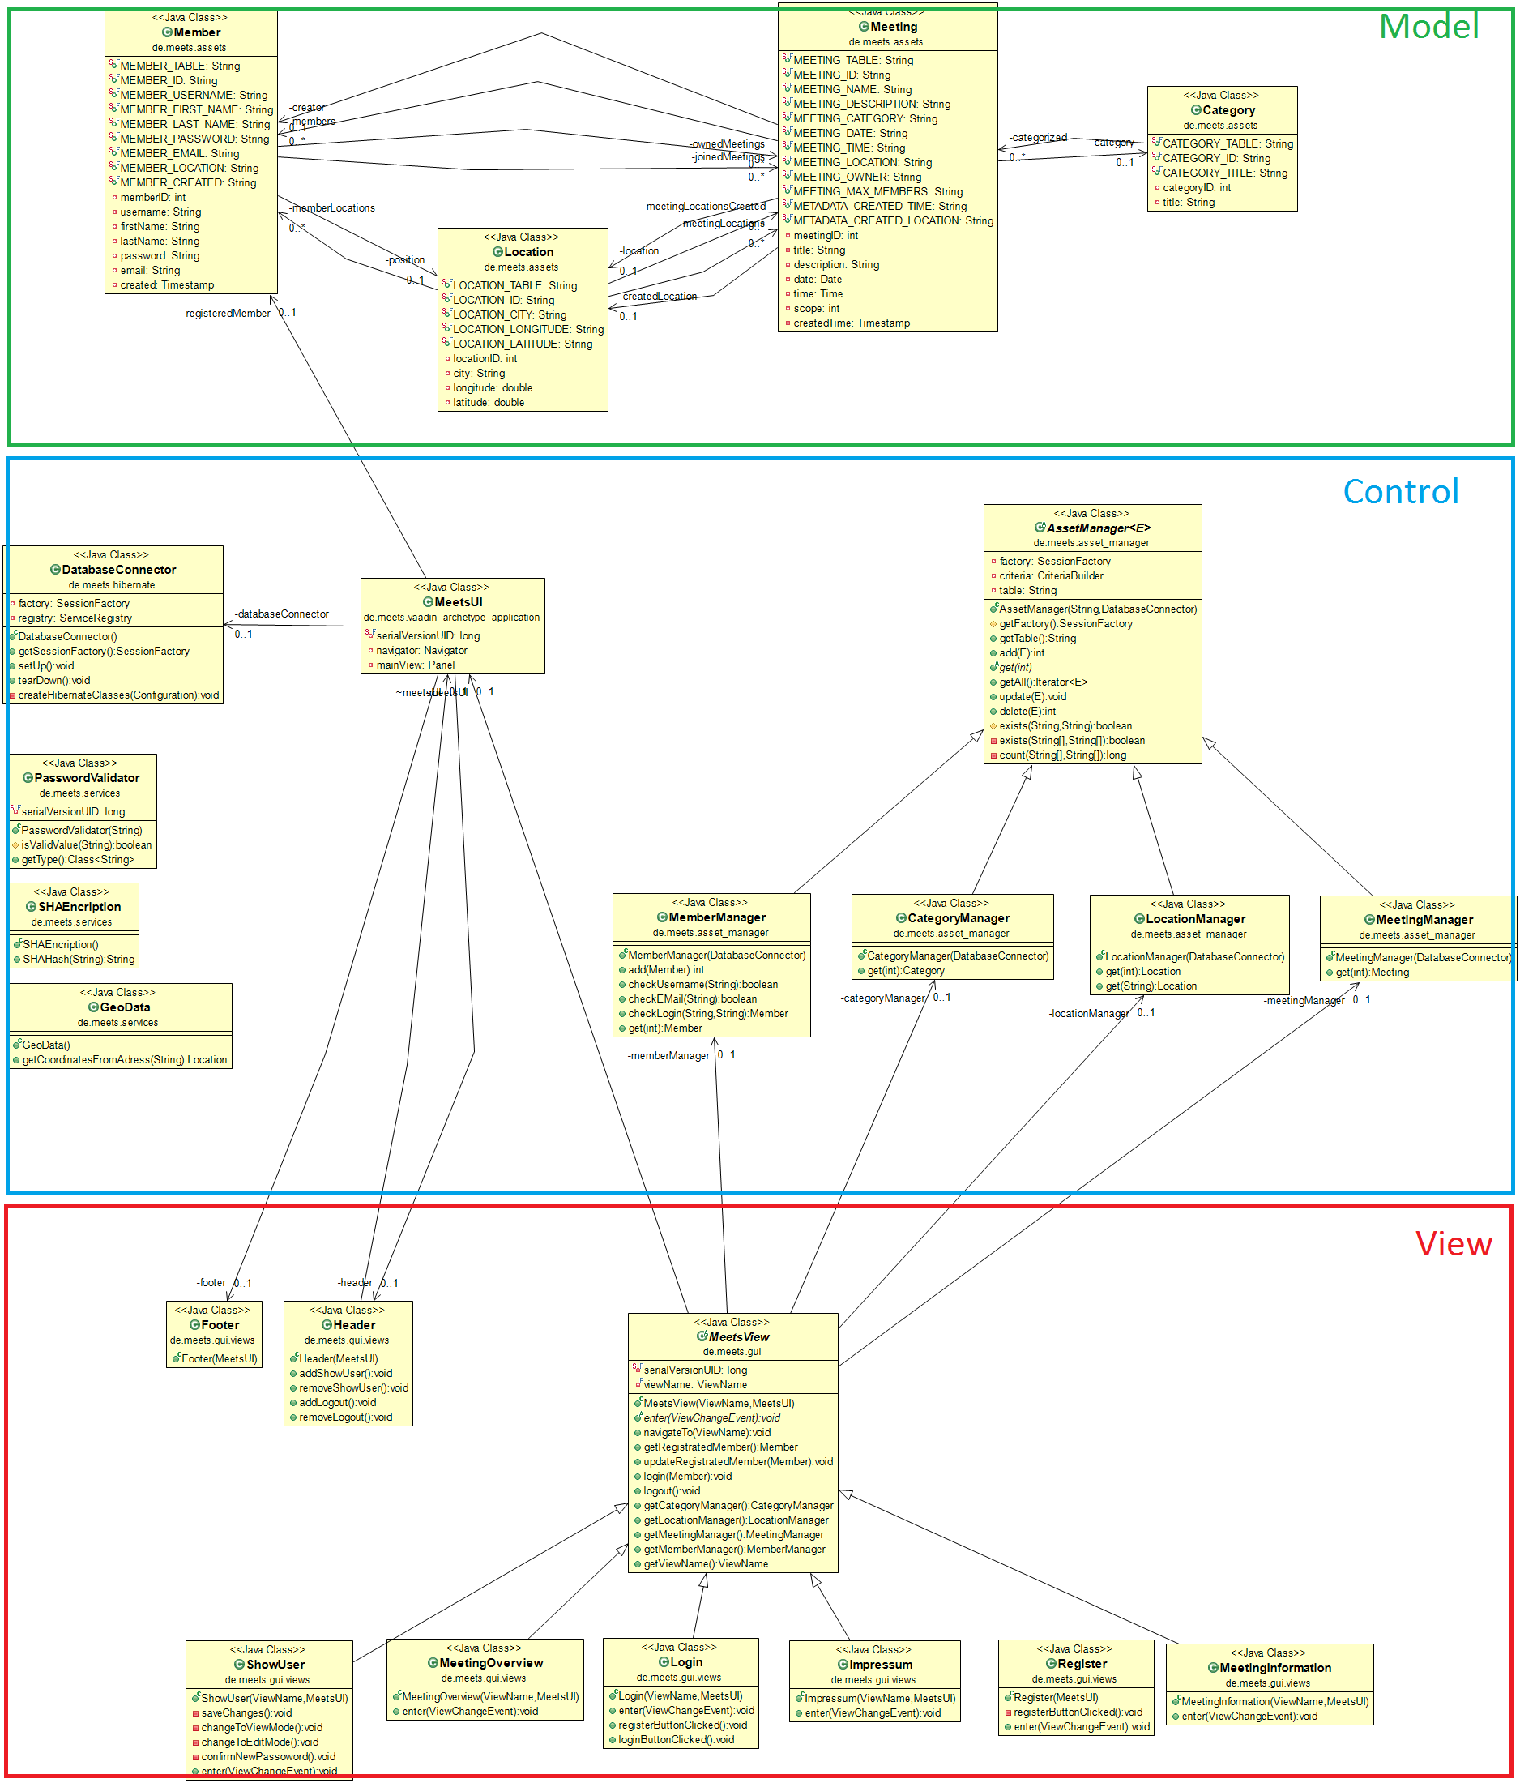

# Process View

n/a

## Deployment View

# C:\Users\D064880\AppData\Local\Microsoft\Windows\INetCacheContent.Word\deployment_chart.pngImplementation View

n/a

# Data View

This is a representation of the database schema in form of an ERM diagram. It displays the implementation of the model and shows relations between the objects in a comprehensive way.

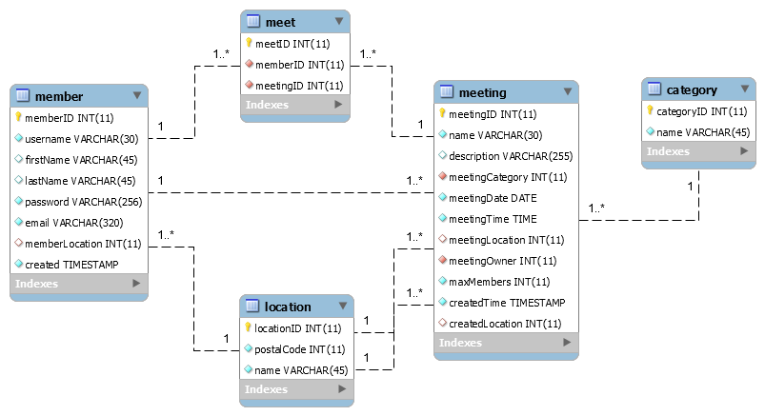

# Size and Performance

n/a

# Quality

n/a